**Hardin Valley Elementary School**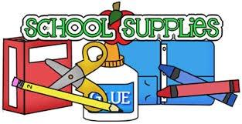

**2022 - 2023**

**Kindergarten Supply List**

**\*Send on your child’s second staggered day.**

**>>>>>>>>>>>>>>>>>>>>>>>>>>>>>>>>>>>>>>>>>>>>>>>>**

**Please label the following items with your child’s name:**

*1 pair of round Fiskars scissors

*1 set of headphones

*A change of clothes in a Ziploc bag

*1 plastic spacemaker school box (5X8 regular size)

*1 backpack (big enough to hold a binder, no wheels)

**Do not label these items:**

*4 boxes of 24 count Crayola crayons

*10 glue sticks (no gel)

*1 box of Kleenex tissue

*2 packages of pre-sharpened pencils (preference is Ticonderoga)

*1 package of markers

**\*Girls:** 1 roll of paper towels

1 package of sandwich Ziploc bags

1 box of gallon Ziploc bags

**\*Boys:** 1 package of quart Ziploc bags

1 package of gallon Ziploc bags

1 box of baby wipes

**These items are optional donations for the classroom:**  *black Expo dry erase markers, pink pearl erasers, colored pencils, colored highlighters, extra markers, extra glue sticks